Greetings Everyone ,

This is the Third and Final Email MOAA Notes/Flyers for JULY 2026 Orange & Orlando Mayors Veterans Council, Seminole & Osceola Veterans Councils. I noticed some of the flyers didn't make it in my previous email (using Word) so I'm adding to this one.

As a reminder, this monthly email normally goes out on the first Wednesday of the month, and please forward me your input/flyers by COB on the First Tuesday of the month. Please forward this email to others to help keep our veteran community informed. I'm happy to add new email addresses to the 300+ that receive this email!

The Ibogaine Florida Veteran Initiative
In honor of my 41st birthday and our nation's 250th tomorrow (😁), I am asking everyone to sign our petition for the Operation Integration Act proposal. The presentation provides a QR code and link to the petition (http://bit.ly/4b8BkzA) and see the attachment above.
Following President Trump's April 2026 executive order fast-tracking psychedelic therapies, our goal is to establish the necessary training and infrastructure in Florida. Given our state's high veteran population and status as a health destination, we have the opportunity to lead by implementing proactive guardrails and oversight before new clinics and providers emerge. The petition calls for dual-lane oversight from licensed healthcare professionals under the Florida Department of Health (DOH) and certified guides and recovery peers under the Florida Certification Board. Psychedelic therapies are already widely used in our state either underground or through entheogenic churches. The signing of the executive order and its upcoming codification will further accessibility nationwide. However, we must ensure our state is structurally prepared to serve our residents so that this doesn't become the next subscription drug.
Happy to answer any questions anyone may have or schedule a meeting for a presentation. What a great time to be an American and take part in this historical coalition!
Semper Fi,
Marisol Salgado Garcia
USMC-Maj (Retired, Mustang)
Florida for Ibogaine

From Lorraine - Marisol has briefed a myriad of various veteran organizations, veteran councils, the VA and legislators (to name a few) throughout Florida, and she is gaiining traction within encouragement to go forward with legislation authorizing Ibogaine treatments for PTSD, TBI, and other Trauma-Related Conditions for our Florida veterans. I personly know 3 local veterans who all have a 501(C)3 veteran organization (widely known in Florida) that recently went through the Ibogaine treatment. They said after dealing with PTSD and other Trauma-Related Conditions throughout their military and civilian life, they were at the end of their tether dealing with it using traditional methods. They were transformed by the Ibogaine treatment and "finally able to get relief" that no other therapy gave them.

This is the documentary Marisol recommeds all of us to watch as it follows Marcus Capone's journey with Ibogaine. He and his wife, Amber, are the founders of VETS (Veterans Exploring Treatment Solutions). I'm also including a link to an interview with Dr. Huberman and Dr. Nolan Williams, the man behind much of the latest Ibogaine research which was used during In Waves and War.

In Waves and War https://www.inwavesandwarfilm.com/
Dr. Hubermand & Dr. Nolan Williams https://www.youtube.com/watch?v=GkG1hMhIQ_Q

The Ibogaine Florida Veteran Initiative "Cliff Notes":
There are currently 15 U.S. States advocating for the approval of Ibogaine as an alternative treatment for PTSD, TBI, and other Trauma-Related Conditions.
The Florida for Ibogaine Coalition is a group of individuals and organizations dedicated to advocating for the medicalization of Ibogaine in Florida. They aim to support FDA-approved Ibogaine research and expand access to innovative treatment options for substance use disorder and mental health conditions. The Florida coalition is actively working to connect with legislators and congressmen to push for legislation and the inclusion of Ibogaine in the medical treatment of PTSD, TBI, and other trauma-related conditions. They emphasize the importance of a coalition approach to ensure the success of Ibogaine's potential in treating these conditions.

Celebration Independence Day Parade : Downtown Celebration is the location. Celebration Avenue to Front Street.

Thanks, Susan!
 |  | Susan Finnigan  Data Product Expert  https://calendly.com/suzygm78/30min
  
  
  2392075805
  susan@lynnamorris.com

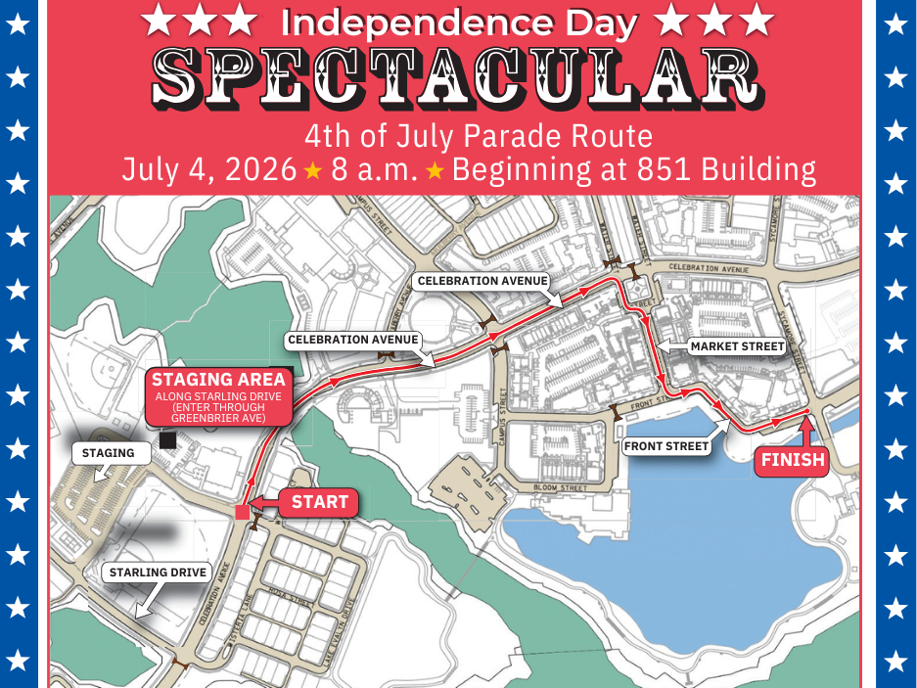

﻿
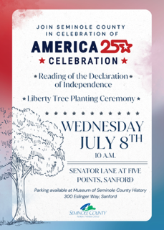

Orlando Morale Welfare & Recreation (MWR) July Price List

It's that time of year when we think about upcoming vacations, and for those of you that are staying close, I've attached the most recent MWR Price Listing. I attached attach the July document sent by MWR.

From MWR Recreational Aid Naysha: Hello, attached below is our current price list with all the attractions we offer. If interested in Disney World pricing, be sure to email us the specific dates and parks you're interested in since the pricing varies on so. Certain tickets are subject to eligibility; those would be the two promotional specials for Universal and Disney. Those promotional specials can be found on the first page of our price list; please keep in mind those are subject to eligibility. All ticket pricing is always subject to change, feel free to contact us if you have any further questions or concerns.
You must meet a specific eligibility criterion for any promotional military tickets. To purchase tickets, you must also have a valid military ID (DEERS issued DoD or VA Health ID that is service connected) it cannot be expired. Also, for Disney you will not find pricing on our pricing sheet. Disney pricing is based on the day and park you would like to visit. Should you have that information feel free to email us mwrorl@gmail.com with it and we can get you the pricing. For Universal's Epic Universe, we only offer those tickets in packages, if those are of your interest, the pricing and packages are also in the price list below. We do not offer single day admission to Epic. Most of our tickets require you to select the specific day you want to go to the park. Should you have any other questions feel free to email us. These tickets are only for Orlando and surrounding areas. There are no taxes and no fees included and the rate you see will be the flat rate per ticket. The Orlando MWR Office is located Inside the Orlando NEX.
GPS Address: 8717 Avenue C. Orlando Fl 32827 and the Physical Address is 7151 Earhart Drive, Orlando Fl. 32827
MWR Orlando Office Hours- Monday-Saturday 10AM-5PM
(407) 855-0116 or (407)-851-4396
MWR Orlando Phone Ordering- Monday-Saturday 9AM-4:30PM
MWR Orlando is CLOSED Sundays and on all FEDERAL Holidays

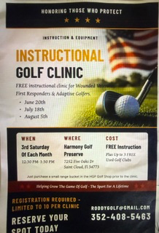

Orlando VA Medical Center – Lake Nona OneBlood Big Red Bus stops by on July 7 from 9 AM – 2 PM.

Be someone’s hero in less than an hour. Join us at Orlando VA Medical Center – Lake Nona when the OneBlood Big Red Bus stops by on July 7 from 9 AM – 2 PM.

Every donation can help save lives — and as a thank you, donors receive a $25 eGift Card, limited edition T-shirt, and free wellness checkup.
Make your appointment today and help make a difference.
Visit and use sponsor code 35379

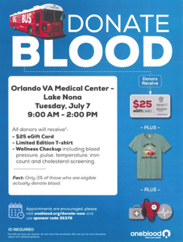

https://www.oneblood.org/donate-now.html

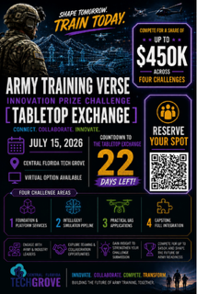
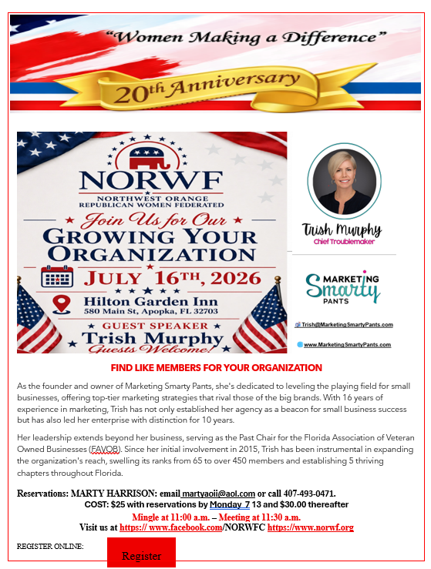

Save Lives - Bridge Divides


DecisionTactical.com
Note: Decision Tactical is only bound by signers listed at this link when signing.

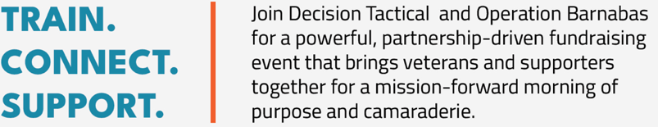
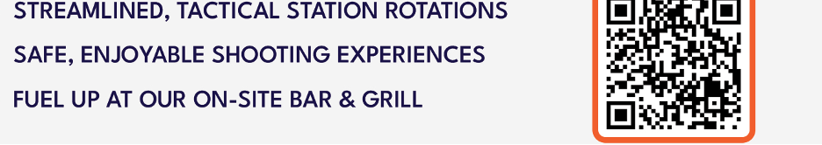
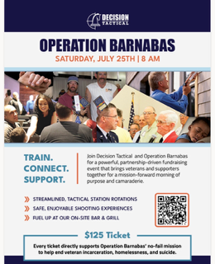

2026 Florida Department of Veterans Affairs (FDVA) Veterans Benefits Guide

The 2026 Florida Veterans Benefits Guides are now in the second printing, and will be available to be shipped in July. With nearly 1.4 million veterans, Florida is the most veteran-friendly state in the nation. The Florida Department of Veterans’ Affairs (FDVA) www.floridavets.org is the premier point of entry for Florida veterans to access earned services, benefits and support. This annual guide (attached) helps connect Florida’s veterans and their families with earned federal and state benefits, services and support. It also contains useful phone numbers and website addresses for additional information. Please forward the attached pdf file to fellow veterans and their families. FDVA’s monthly Forward March Veterans’ Newsletter continues to grow subscribers. The email subscription-based newsletter has more than 62,000 subscribers and is available by visiting www.FloridaVets.org . In addition to the informative monthly email, please explore the website to gain additional information about benefits, points of contacts, and specific information vital to our veterans and their families. To View the 2026 Guide:

Click here to view the 2026 edition of the Florida Veterans’ Benefits Guide:
https://floridavets.org/wp-content/uploads/2012/08/FDVA-Benefits-Guide.pdf?v=2026

For bulk orders more than 50 copies, please contact LeeAnn.Sferrazzarios@fdva.fl.gov
For orders less than 50 copies, please contact Mary.Frazier@fdva.fl.gov

SAVE THE DATE: SEA WAVES 1ST ANNUAL MILITARY EATING DISORDER AWARENESS GALA NOVEMBER 7TH TAMPA
SEA WAVES is hosting our first annual gala, Beneath the Surface, on November 7th, 2026, at the Florida Aquarium in Tampa, Florida.
This evening is dedicated to raising awareness around eating disorders in the military community. The theme, Beneath the Surface, reflects both the unique aquarium setting and the unseen struggles many service members, veterans, and families carry beneath the surface of military life.
Funds raised during the gala will directly support SEA WAVES’ Lighthouse Project programs. These initiatives focus on reducing isolation, strengthening connection, and advancing suicide prevention within the military community.
If there is interest, we do still have intentionally limited, first-come, first-served sponsorship opportunities available here:
https://tinyurl.com/BeneathTheSurfaceGalaInfo
Tickets, sponsorship selections, and event registration can be found here:
https://givebutter.com/BeneathTheSurface
While the event is being held in Tampa, we would truly appreciate any help spreading the word. We also have limited opportunities remaining for sponsorship, program advertisements and are actively seeking additional items for our silent auction.
Thank you so much for your support and consideration.
“Be the lighthouse: BRAVE against the storms, STRONG against the waves, and a beacon of HOPE for those lost in the darkness.”
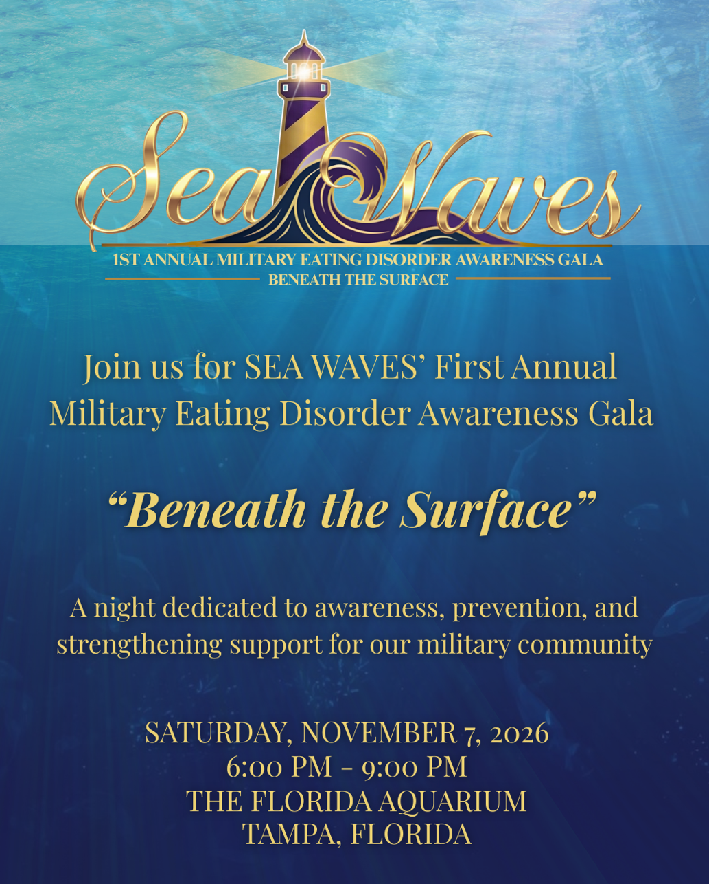
BeneathTheSurfaceGalaInformation.pdf

Thank you for all you do for our veteran community, and I hope to see you soon!

Warm Regards,


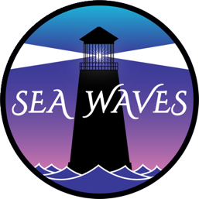
  Leah Stiles
  Founder / CEO, SEA WAVES, Inc
  Retired Navy Senior Chief | Advocate | Keynote Speaker | Best Selling Author
  Battle Scars & Body Wars: A Personal & Professional Journey Shining a Light on Eating Disorders in the Military
  Need a Light; Be a Light
  www.sea-waves.org | leahstiles@sea-waves.org
  903-689-2837 | Connect on LinkedIn
  Schedule a meeting:
  30-Minute Call | 60-Minute Meeting
  Need support? Text WAVES to 741741 for Crisis Text Line
  Donate: https://givebutter.com/bealight77
  CAGE Code: 11VS0 | EIN: 93-2144377
  Follow SEA WAVES:
  
  
  
  

MAJ (ret) Lorraine Holland, USA
Military Officers Association of America (MOAA)
President of Central Florida Chapter (CFC)

Visit us at our websites
Chapter: www.moaacfc.org
Council: www.flmoaa.org
National: www.moaa.org
(407) 221-1388 cell
lorraineholland@hotmail.com
Never Stop Serving!

Follow MOAA on Facebook and Gain a Follower Back!

Like all of our VSO’s, we are trying every which way to recruit new members. Be part of the solution and please give Florida MOAA a ‘Following Us’ on our Facebook Page FB@MOAA Florida Council of Chapter and Follow Us! We will respond in kind!

